TITLE of paper
(ARIAL, 14 pt, all caps)

A.B. AUTHOR, C.D. AUTHOR (12 pt, all caps)
Department, Organisation (10 pt, italics)
Street, Postal Code City – Country (10 pt, italics)

E.F. AUTHOR
Other department, Other organisation (10 pt, italics)
Street, Postal Code City – Country (10 pt, italics)

ABSTRACT

Your manuscript must be in English. Please use UK spelling. It should start with a short abstract of 150 words maximum describing the key elements of your contribution and its conclusions. The text should be typeset in block mode. Typeface throughout the text is Arial. For this paragraph the font size is 10 pt, with left and right indents of 1.5 cm.

- Introduction (12 pt, bold)
- Settings
Your manuscript should then continue on the same page with an introduction. The typeface throughout the text is Arial. Setting of paper size is DINA4-size only. The top, left and right margins are 2.5 cm while the bottom margin is 2 cm. For all following text sections the font size is 11 pt, single line spacing with a spacing of 0 pt before and after the paragraph mark, and the lines are justified in block mode.

- Figures and tables

Figures and tables should be inserted into the text at the appropriate place. They should be clearly identified with a caption, as shown below.

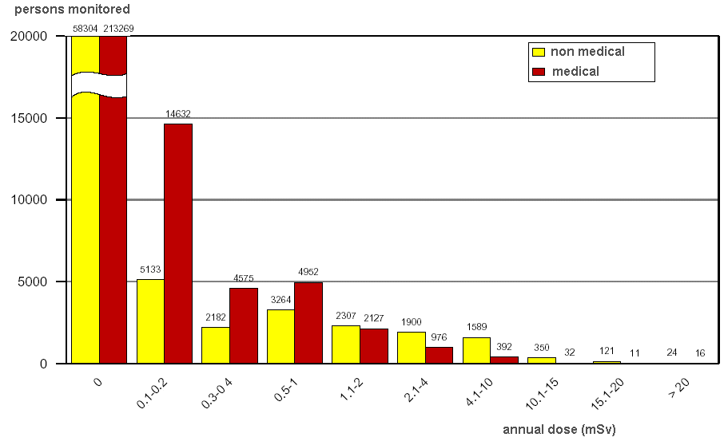
Fig 1. Caption for figure one

xxx | yyy | zzz
aaa | 123 | 456
bbb | 789 | 012
ccc | 345 | 678
ddd | 901 | 234
Tab 1: Caption for table one

- Electronic form of contribution

For the conference proceedings (Transactions) an electronic version as a MS WORD.doc file of your final paper is required together with an ADOBE Acrobat .pdf version (the latter will allow checking the documents (and in particular graphics) are not distorted). Please use UK spelling.

- Length of your presentation

We recommend limiting your paper to five pages for posters and ten pages for oral presentations, including the title page, all tables and figures and the references.

Your PowerPoint presentation will be (exclusively) in English and not last more than the time assigned.

- Visual aids for oral presentations, special instructions for poster presentations

The visual aid available to you as a speaker in an oral session is PowerPoint projection.

Posters will be on displays throughout the workshop. They should be installed before the beginning of the day 2 and should be taken away only at the end of the last session. The surface available /size of the poster panels is 2000mm (H) x 1000mm (W) (portrait format). At least one author per paper is requested to attend personally the whole poster session to permit proper presentation and discussion of the poster during the said poster session.

- References

Please number your references and cite them in brackets. The list of references should be at the very end of your manuscript under the section heading “References”.

- Deadline
Your full paper should be submitted by 15 May 2019 at JRC-KRU-INSIDER@ec.europa.eu

The INSIDER ExCom will review and potentially comment the paper by mid-June 2019 for submission of the final version by mid-July 2019.

- Registration

Please, register through the INSIDER Mid-term Workshop Online Registration System http://insider-meeting-workshop.evenium.net

